# Time Series Forecasting Using LSTM Neural Networks

By Bhuvana Chandrika (Roll Number: 121AD0019)

**Introduction**

This report presents the results of a time series forecasting assignment using Long Short-Term Memory (LSTM) neural networks. The assignment aimed to forecast traffic speed based on historical spatiotemporal data.

**Data Preprocessing**

Data Loading

The dataset was imported and loaded into the analysis environment. It contained spatiotemporal data related to traffic conditions.  
  
Dataset was downloaded from

| <https://pems.dot.ca.gov:443/?report_form=1&dnode=VDS&content=loops&tab=det_timeseries&station_id=1118886&s_time_id=1693526400&s_time_id_f=09%2F01%2F2023+00%3A00&e_time_id=1697921940&e_time_id_f=10%2F21%2F2023+20%3A59&tod=all&tod_from=0&tod_to=0&dow_0=on&dow_1=on&dow_2=on&dow_3=on&dow_4=on&dow_5=on&dow_6=on&holidays=on&q=occ&q2=speed&gn=hour&agg=on&lane1=on&lane2=on&lane3=on> |
| --- |

**Data Sorting**

The 'Hour' column was converted into a datetime format, allowing for chronological sorting of the dataset.

**Data Exploration**

Basic statistics of the dataset were analyzed to gain an understanding of its characteristics and distribution.

A visualization was created to provide insights into the trends in traffic conditions. The graph displayed Lane 1 Occupancy and Lane 1 Speed over time.  
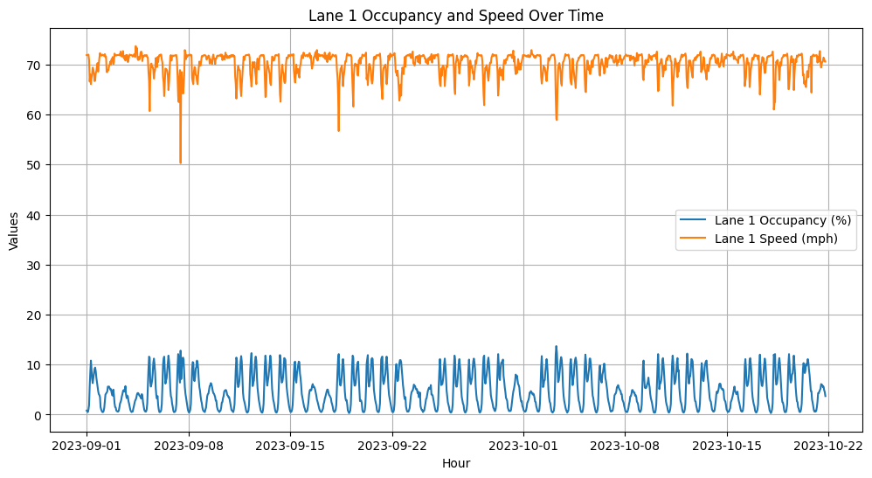

**Data Preparation**

Feature Selection:

Relevant features, including "Lane 1 Occ (%)" and "Lane 1 Speed (mph)," were selected for modeling.

Data Splitting:

The data was divided into training and testing sets to evaluate the model's performance.

Data Normalization:

Min-Max scaling was applied to normalize the dataset, ensuring uniformity and numerical stability.

**LSTM Model**

Model Architecture

An LSTM model was constructed with a single layer comprising 64 units and a Rectified Linear Unit (ReLU) activation function.

Model Compilation

The model was compiled using the mean squared error loss function and the Adam optimizer.

Model Training

The LSTM model was trained for 50 epochs with a batch size of 32, and validation data were used to monitor the training progress.

**Model Evaluation**

R-squared (R^2) Calculation

R-squared, a measure of the model's performance, was calculated for the LSTM model. An R^2 score of approximately 0.766 was achieved on the test data, indicating the model's ability to explain 76.6% of the variance in traffic speed.

**Model Visualization**

To visualize the model's performance, a graph was created, showing the comparison between actual and predicted traffic speed. This visualization confirmed that the LSTM model effectively captured traffic speed trends.  
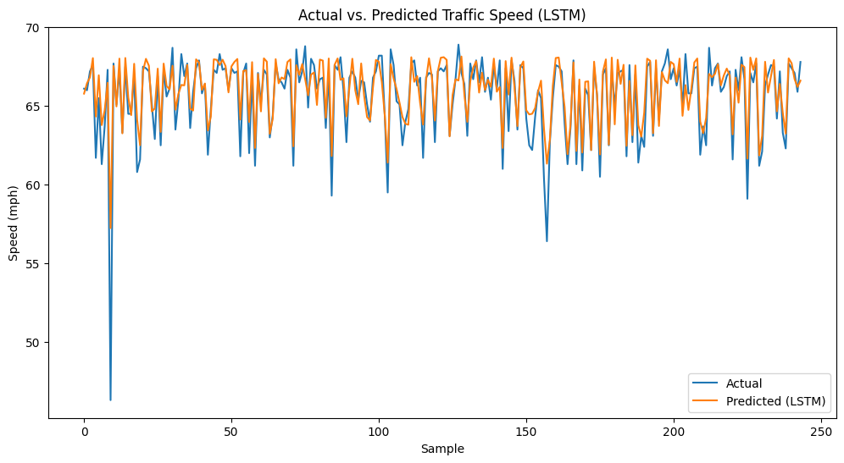

**Conclusion**

The assignment successfully employed LSTM neural networks for short-term traffic speed forecasting. The model's performance, with an R-squared score of 0.766, demonstrates its potential for various applications, including traffic management and congestion prediction. Further refinements and optimizations, as well as the inclusion of additional data and features, may enhance its performance for real-world traffic forecasting tasks.